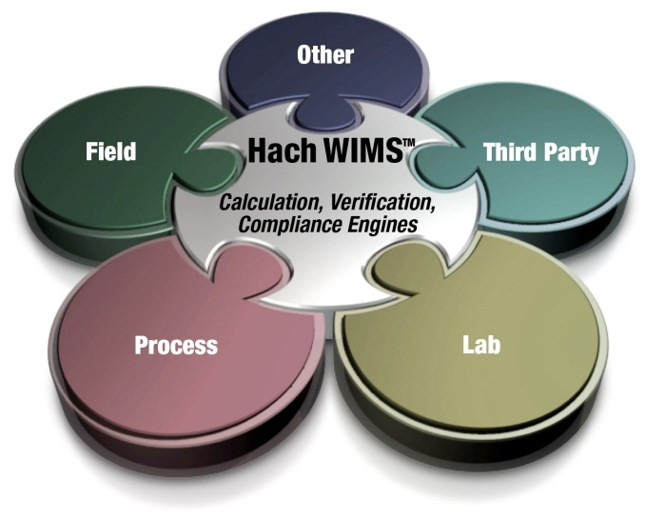

Administrator’s Guide

Hach WIMS­­TM Multi-User/Enterprise

With Oracle Database Support

|  |  |  |
| --- | --- | --- |
| **Version** | **Date** | **Comments** |
| 1.0 | July 15, 2014 | WIMS 7.5 |
|  |  |  |

**Table of Contents**

1.1 Introduction 3

1.2 Hach WIMS System Requirements 4

1.3 System Overview 5

1.4 Installation Preparation 7

1.5 New Installation 8

1.5.1 Installation Steps 8

1.5.2 Enable WIMS to view/kill sessions in Oracle 10

1.6 Hach WIMS Server Setup 11

1.6.1 Create Hach WIMS Root Tables 11

1.6.2 Creating New Hach WIMS Facilities 12

1.7 Database Upgrades 15

1.8 Hach WIMS Services 16

1.8.1 INI Files 16

1.8.2 ADOCALC 17

1.8.3 DBAHelper 17

1.8.4 Email Gateway 17

1.8.5 GNR Server 18

1.8.6 Scheduler 18

1.8.7 Watchdog 18

1.9 GNR Server Service Setup 19

1.9.1 GNR Server Service as Administrator 19

1.9.2 GNR Server PDF Printer 19

1.10 Updating the Hach WIMS Client 23

1.11 Hach WIMS User Messages 24

1.12 Backing up a WIMS Facility 24

1.13 Restoring a Hach WIMS Backup 24

1.14 Export/Import Utility 24

Appendix A: Enabling Relaying on your Email Server for Hach WIMS 26

# 1.1 Introduction

The Hach Water Information Management Solution™ with Database Support (referred to as Hach WIMS­­TM or WIMS in this manual) is a data management system specifically designed for water and wastewater facilities. The software allows you to track, report, graph, and analyze facility data including SCADA, lab, and operator entered data. The Hach WIMS system consists of a rich front-end client running on each user’s PC with a backend Oracle database. This manual is intended to assist the administrator install, configure, and maintain the WIMS­­ system.

This manual covers two editions of Hach WIMS: WIMS Multi-User with Oracle Database Support and WIMS Enterprise with Oracle Database support. The two editions are very similar for administration and vary only in the number of users and facility databases that can be purchased.

**Hach WIMS Multi-User with Oracle Database Support:**

Base features:

* Unlimited Variables and Facility Database Size
* Support for Oracle 9i or later
* Scheduled Output of reports and graphs (GNR Server)

Allows you to purchase:

* Up to 20 Concurrent Users
* Up to 20 Facility Databases
* Unlimited number of interfaces
* Load Balancing Calc Engine

**Hach WIMS Enterprise with Oracle Database Support:**

Base features:

* Unlimited Variables and Facility Database Size
* Support for Oracle 9i or later
* Scheduled Output of reports and graphs (GNR Server)
* Load Balancing Calc Engine

Allows you to purchase:

* Unlimited Concurrent Users
* Unlimited Facility Databases
* Unlimited number of interfaces

**Knowledge Base**

Our Knowledge base website has various articles and information to help the user. To access the knowledge base: <http://www.opssys.com/instantkb/> - use browse or search functions to find information for the various components of the Hach WIMS System. Throughout this guide are links to Knowledge Base articles for additional information and support.

# 1.2 Hach WIMS System Requirements

**Hach WIMS Client and Components**

**Operating system:**

* Microsoft Vista
* Microsoft Windows Server 2003 Service Pack 1
* Microsoft Windows Server 2003 R2 Service Pack 2
* Microsoft Windows Server 2008
* Microsoft Windows Server 2008 R2
* Microsoft Windows Server 2012
* Microsoft Windows Server 2012 R2
* Microsoft Windows 7
* Microsoft Windows 8, 8.1
* See <http://www.opssys.com/instantkb/Article.aspx?id=12215> for a complete list

**Data access:**

* Access to an Oracle Database Server (release 9i or later)
* Oracle 32-bit Provider for OLE DB compatible with your version of Oracle. See your Oracle Database administrator for the proper versions

**Hardware** (Minimum requirement for OK performance):

* 1 GHz processor (32 or 64-bit)
* 1 GB System RAM
* 10 GB of available disk space
* Screen resolution of 1024x768 with 32bit color depth
  + - * DVD-ROM

**NOTE:** Hach WIMS­­ interfaces, Calc Engine, and GNR Server are designed to run as Windows services.

For Database server see the hardware requirements for your specific version and edition of ORACLE Server.

**Hach WIMS DATABASE NETWORK BANDWITH SPECS**

Hach WIMS is based upon true client-server architecture. The client software has a large footprint and requires a speedy connection to the database server.

It is difficult to precisely state the minimum network bandwidth requirements for Hach WIMS. It was developed to work efficiently on a 10 Megabit network. Depending on your current network bandwidth utilization, even 10 Megabit may not be enough.

We do not recommend deploying Hach WIMS onto T1 bandwidth-rated networks. If you are bound by such network hardware, please consider running the Hach WIMS client on an application server (such as Windows Terminal Server or Citrix).

# 1.3 System Overview

The Hach WIMS data resides in a customer supplied ORACLE 2005 (or later) DBMS. The WIMS database stores data from a variety of sources including LIMS, SCADA, and manually entered. Raw data is calculated as needed and is stored in the database.



**Definitions:**

**Client/server:** An architecture in which the user's PC (the client) is the requesting machine and the server is the supplying machine, both of which are connected via a local area network (LAN) or wide area network (WAN). In this environment, servers are used to store and share data with the client PCs. The important concept of client/server is that both client and server each take on some of the application processing.

**Client software:** It is the Hach WIMS executable (Hach-WIMS_Client­­.exe) thatresides in a user's computer and is used to interact with the database. The client processes the user interface and can perform some or all of the application processing.

**Database Support:** Sometimes referred to as DB Support, allows Hach WIMS to utilize an enterprise Database Management System such as MS SQL Server (Enterprise, Standard, or Workgroup edition) or Oracle. Database Support is an add-on and is part of the software license.

**Concurrent Users:** Multiple users may log into the WIMS system at the same time. These users are concurrent users because they are accessing the system concurrently.

**Server software**: Software that resides in a server and provides services to multiple users on the network. A database server maintains the databases and processes requests from the client to extract data from or to update the database. An application server provides additional business processing for the clients.

**WIndows Services:** Applications that run in the background, that do not require login or have no user interface. Typically these are run on the server. Also known as NT Services.

**Oracle DBMS:** The Oracle Database Management system (9i or later) typically provided by the client.

**SMTP Server:** Server that is used to send email. (Simple Mail Transfer Protocol)

**Server\computer name:** The unique ID of a computer on a network. The computer name can be found in System Properties on the Computer Name tab.

# 1.4 Installation Preparation

Hach WIMS­­ Multi-User is designed run on a multiuser network. The system architecture:.

1. Database Management Software (ORACLE) resides on one machine.

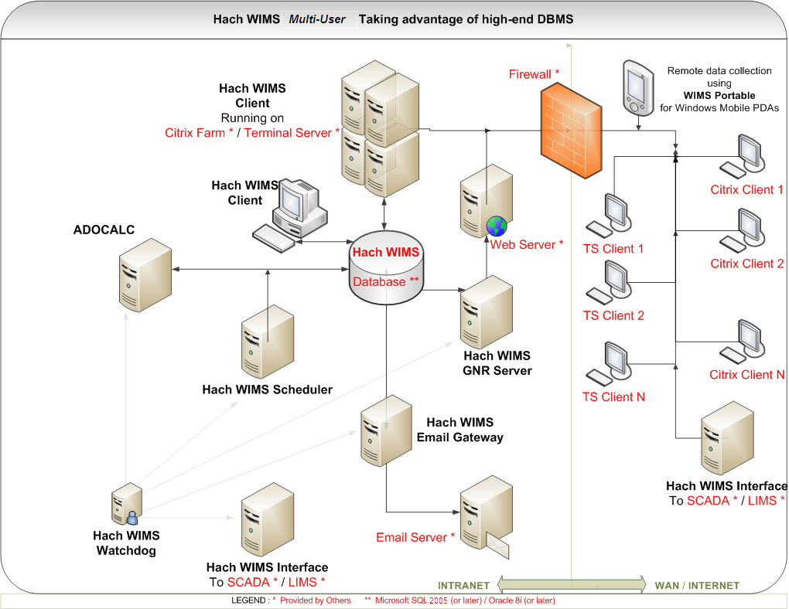

1. Client software is installed on any number of machines. Including terminal service machines.
2. Server software (ADOCALC, GNR Server, etc.) can be split onto multiple computers, installed on an App server, or on the DB Server itself.

Additional definitions of the items and options for Hach WIMS:

**Server Setup:** Utility used to create WIMS­­ tables, stored procedures, upload clients, restore database backups, etc.

**ADO CALC:** The WIMS­­ Calc engine is a Windows Service that monitors the WIMS­­ databases and calculates data as required so it is available for reports, graphs, etc. ADO Calc should be placed on a powerful PC that is close to the Server. **NOTE**: ADO Calc can run on the server, which will reduce network traffic and improve system performance.

**DBA Helper**: A WIMS Windows Service that performs backups of WIMS SQL Express databases. DBA Helper does not work with customer supplied DBMS.

**Live Update:** A WIMS Windows Service that checks the Hach WIMS­­ website for updates of available for install by the user.

**Email Gateway:** A WIMS Windows Service that connects to your SMTP mail server and relays the emails generated by the Hach WIMS­­ Client (when you choose to output a report or graph to email) or emails generated by the GNR Server (e.g. reports or graphs that are output on a scheduled basis)

**Scheduler:** A WIMS Windows Service schedules output of report or graphs, database calculations, or database backups.

**GNR Server:** A WIMS Windows Service that receives requests from the scheduler to output reports and graphs, generates the output, sends the output to a printer, a file, or to email (using the email gateway)

**IABroker:** Facilitates the interaction of 3rd party software’s interaction with the WIMS System. (E.g. IFix)

**Watchdog A** background Windows Service that keeps watch on the connection to the database and will restart the other services in the event of a connection lost.

# 1.5 New Installation

Hach WIMS installation uses the WIMS Platform Installer. This Software assists you while installing the WIMS Software. Use this section to install any component to the WIMS System. The process is the same weather installing one component or all the components.

**NOTE: If you are upgrading from a previous version (OPS SQL), please refer to Upgrading from 6.x.x in the Knowledge base.**

## 1.5.1 Installation Steps

1. Close all programs that are currently running.

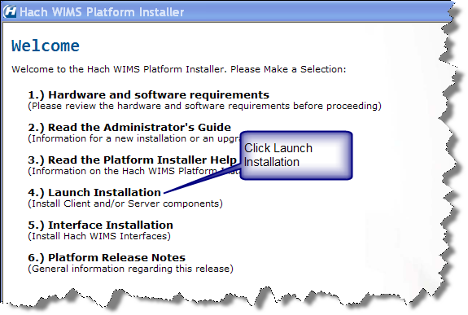

1. Insert the Hach WIMS DVD and the Hach WIMS Platform Installer Welcome will be displayed. If the Welcome screen does not appear, double click on d:\Launcher\Launcher.hta where d: is your dvd drive.

1. Click **Launch Installation** option from the Hach WIMS­­ Platform Installer Welcome.

**NOTE:** You may see a Prerequisites Wizard if any of the prerequisites are not installed. Install using the Prerequisites Wizard. (.Net Framework 2.0 SP1 is a common missing prerequisite).

4. Platform Installer Bootstrapper will be displayed. Click .

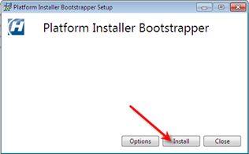

**Note:** Depending on your OS, you may be prompted to allow the program to make changes to your computer (User Access Control). Click Yes if prompted.

1. Review and agree to the License Agreement. Check the Box if you agree and click **Next**.

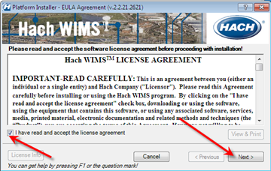

1. The Platform Installer should launch. Enter your Serial number and Browse to your License File (a file with a .License2008 extension, should be located in the root folder of your WIMS DVD). Click the **Next** button. Your Serial Number is on the WIMS DVD Case or it may be emailed to you.

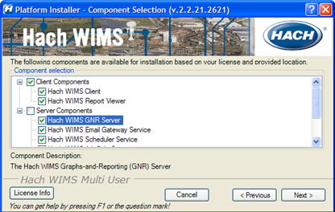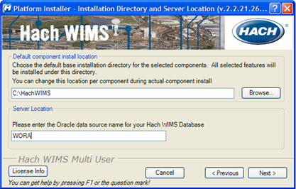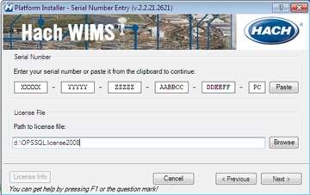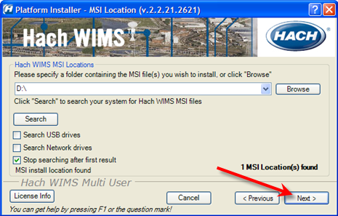

1. The Platform Installer will search for Hach WIMS­­ MSI locations. You may need to browse to the MSI Location using the Browse button. A popup will inform you when a location is found. Click **Next**. If you are installing from the DVD click **Next**.

1. When you have selected the components to install, click the **Next** button.
   1. Server – The Server components maybe split between multiple machines. Each Machine must have a connection to the machine hosting your database. Select the Components for this machine.
   2. Client - If you are installing just the client, only the client components are selected and **none** of the server components.
2. Choose your default installation directory and set your Oracle Server. The directory you choose will be the default and each component will be installed with this directory in mind.

1. The Platform Installer will list the Components that you selected and prepare them to be installed. Click the Begin button. Each Component will have its own Installation wizard. Complete each wizard to continue with installation. Please see the Component Installation section for help with each wizard. Once each component has finished, press the finished button. Hach WIMS is now installed.

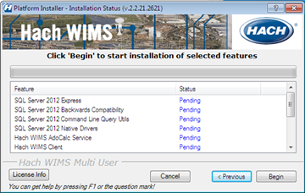

**NOTE**: Depending on your operating system and settings you may need to grant privileges to users so they can use WIMS. WIMS needs users to be able to create/write/modify files in the HACHWIMS folders and subfolders. This most commonly needs to be done in Windows 2008 R2 and Windows 7:

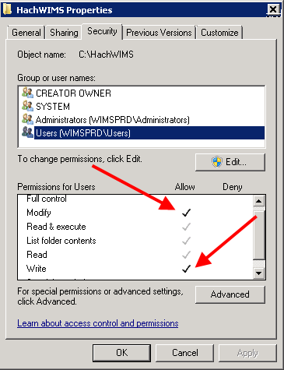

## 1.5.2 Enable WIMS to view/kill sessions in Oracle

In **Oracle**, the **OPSROOT** user needs to be granted a **SELECT** privilege in the system table **sys.v_$session.** This table contains information about client connections to WIMS.  
  
**You will not be able to log into WIMS, unless this privilege has been granted.**

This privilege also matters during Database Upgrade, since WIMS will need to be able to kill its client connections in order to prevent a failure during the upgrade process.  
  
1) Contact your Oracle database administrator to perform this task.  
2) Run **sqlplus sys/change_on_install@oradev**  
-where **change_on_install** is the default password for the oracle sys user. You most likely will have to acquire this password from the database administrator.  
**-**where **oradev** is the name of the oracle database

**Note: ORACLE 9i and onward requires sys login to use AS SYSDBA.   
Example: sqlplus "sys/change_on_install@oradev as SYSDBA"**

**NOTE: USE THE DOUBLE QUOTES AS SHOWN IN THE EXAMPLE ABOVE!**

3) Execute **grant select on v_$session to OPSROOT;**4) execute **grant select on dba_segments to OPSROOT;**

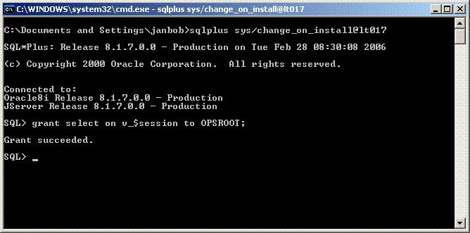

# 1.6 Hach WIMS **Server** Setup

The Hach WIMS Server Setup program allows the administrator to setup the Oracle database for use with WIMS, create new databases, restore backed up databases, import OPS 32 databases, and perform database upgrades.

## 1.6.1 Create Hach WIMS Root Tables

The utility needs access to an existing **Oracle service**. Once you specify the service name, the utility will try to connect to this service as **OPSROOT** user. If it cannot connect, the utility assumes that WIMS structures have not been installed on this service.

The Server Setup will create all needed structures on this service. It requires a username and password of a user with high Oracle privileges (DBA).

**Note:** This login information is not stored by any Hach WIMS product once the structures have been created.

Server Setup will create a new Oracle user called **OPSROOT**. It will create a table space (**OPSMASTERSTORAGE**), which will be used to store all physical data for WIMS. The OPSMASTERSTORAGE is created on the server regardless of where the Server Setup is run from.

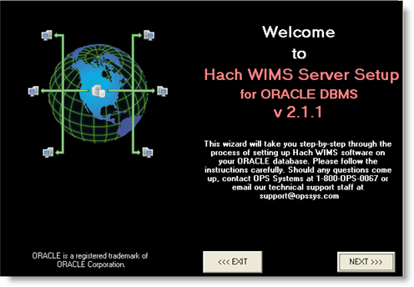

1. Run Hach WIMS Server Setup (Oracle Edition). By default: Start, Programs, Hach Company, Hach WIMS, Hach WIMS Server Setup (Oracle), Server Setup (Oracle Edition). Click **Next.**

1. Connect to the Oracle Database:
2. If this is the first time you are connecting Server Setup to this Oracle Instance, you will be prompted for an Oracle admin username and password. Enter your Oracle Username and password and click **Next**:

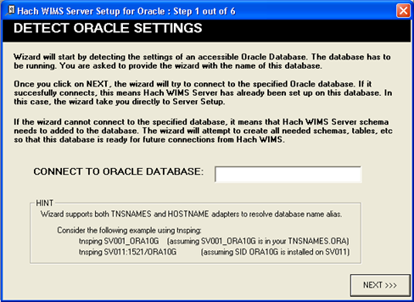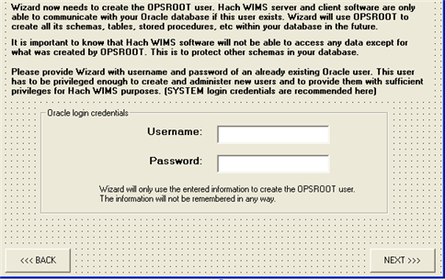

1. Server Setup will create the Master Tablespace for WIMS. Enter the folder (Directory) or where the tablespace datafile should be placed and click **Next**.

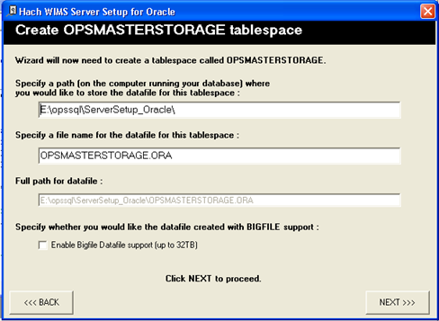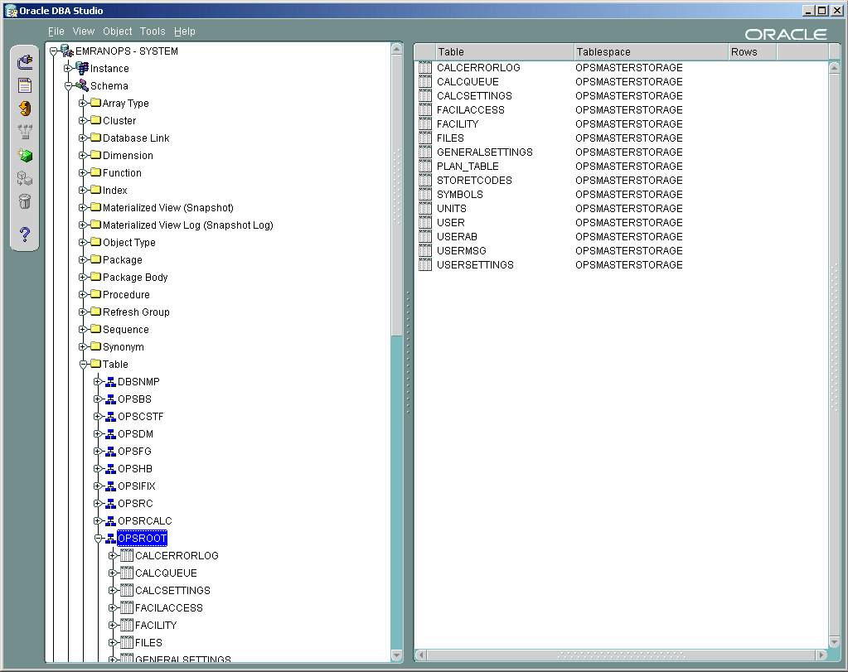

Server Setup will create all tables, indexes and stored procedures that are needed by WIMS. The following figure displays a typical Oracle Setup for OPSROOT as shown in Oracle’s DBA Studio.

To import OPS32 security (which includes OPS 32 users, their facility access privileges and their shortcuts), click the **import OPS 32-security** checkbox. Then browse for the location of the User.97 file, which stores this security info.

Server Setup will ask you to restart the program so it can synchronize with the database server’s time.

## 1.6.2 Creating New Hach WIMS Facilities

Specify a unique identifier and a facility name for the new facility. The unique identifier is used to create a database under which all tables, stored procedures, and triggers will be held for the new facility.

**Unique Identifier:** This field can only contain letters. No numbers or other special characters. You are limited to a maximum of 8 characters – we recommend you use 4 characters or less.

**Data Source:** The ORACLE Server that will be hosting this database.

**Facility Name:** You should use your common facility name. If you call your plant Rocky Creek WWTP – type in Rocky Creek WWTP.

Use the server setup utility to create a new Hach WIMS­­ database. Specify a unique identifier, data source, and a facility name for the new facility.

1. Run **Hach WIMS­­ Server Setup**.

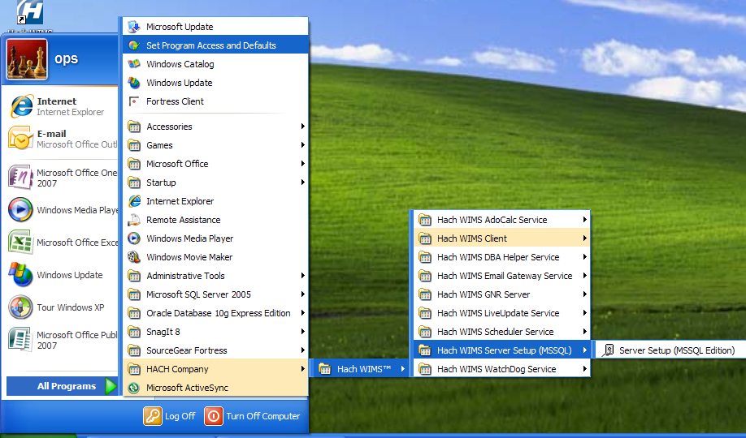

2. Click **Next** to login from the Welcome screen**.**



3. Enter your Oracle Database Name and click **Next**.

4. Enter a Hach WIMS­­ Super Username and Password. The default username is Super, password Super. Click **Next**.

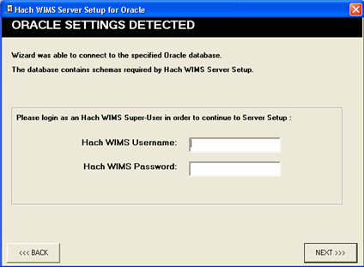

1. Click on the New Facility Tab to name your database.

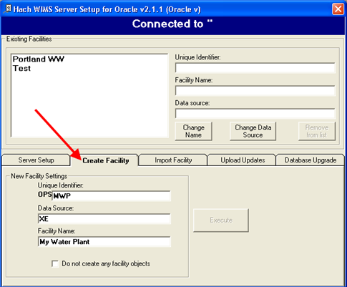

**Facility Name:** Use your common facility name. If you call your plant City WWTP – type in City WWTP.

**Unique Identifier:** A short identifier for the new database. This field will be defaulted when you enter a Facility Name. This field can only contain letters. No numbers or other special characters. You are limited to a maximum of 8 characters.

**Data Source:** This should match the server you are connecting to.

1. Click **Execute**. The Server Setup will create a new database and display a success message. Click **OK**.
2. All new facilities are upgraded to the latest database version during their creation. This means you should be able to login to your new facility immediately.

As facilities are created, Hach WIMS­­ Server Setup creates a database and all tables, stored procedures, and triggers needed for that database. For example, Hach WIMS­­ Server Setup created OPSRC database that holds all the tables needed for the Rock Creek WWTP facility. The following figure displays the tables that are created by Server Setup for the OPSRC facility.

1.7 Database Upgrades

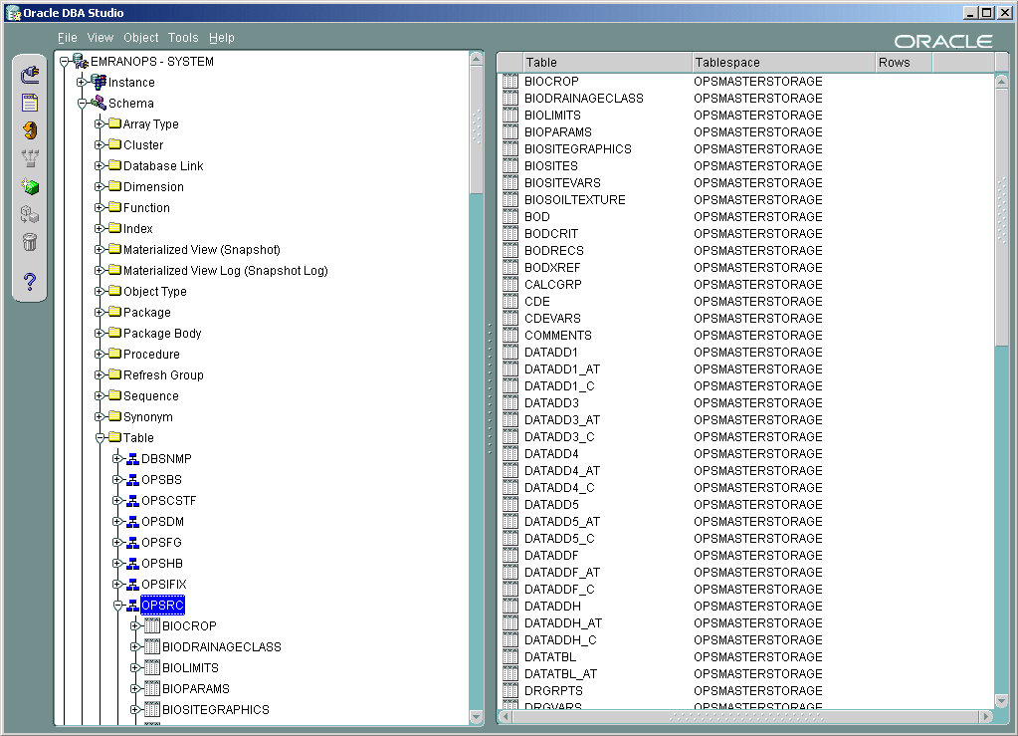

The facilities in the Hach WIMS system may not be up to date with the current version of Hach WIMS. Upgrade these facilities using Server Setup in order to use them.

NOTE: All users must exit WIMS­­ before Proceeding.

1. Start **Server Setup**.



1. Click **Next** to Start Server Setup:



1. Input Server/Instance Name. Click **Next**.



1. Input Username and Password and click **Next**. The default Username and Password are:

Username: Super

Password: Super  
  
  
  
  
Select the **Database Upgrade** Tab.

1. Click the **Refresh** button to get a list of databases that are not up to date.
2. Press the Database **Upgrade** Button. This will upgrade all the databases in the list.

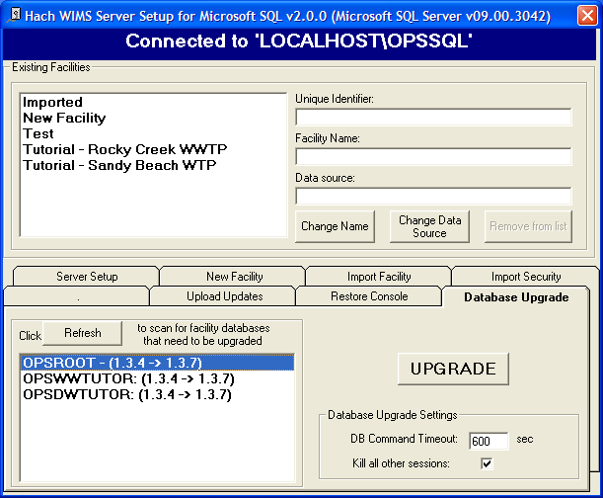

1. The system needs full access to the database. It will terminate the connection for anyone currently logged in. It also informs you that you will need to restart your ADOCALC and GNR services once the upgrade is complete. If you understand these requirements, click the **Yes** button.
2. Upon Success you will be able to log into any of the upgraded facilities.

# 1.8 Hach WIMS Services

Hach WIMS installs several Windows services. These services perform a variety of tasks that are essential for Hach WIMS to run properly. To view your services and to verify they are running, start “**Services.msc**”.

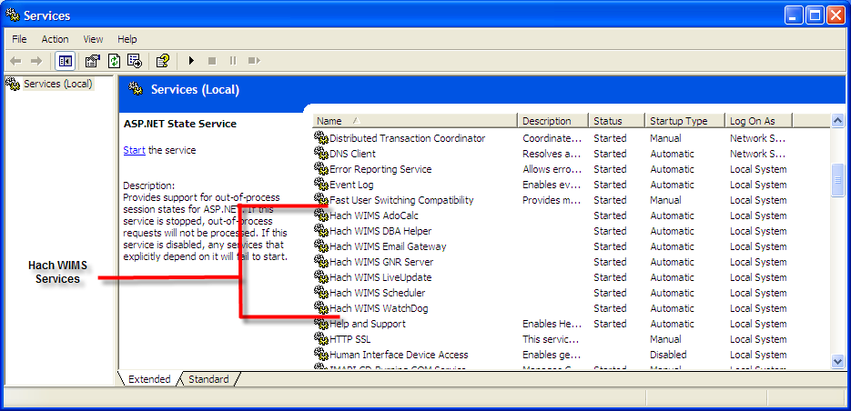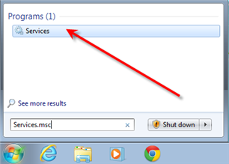

Hach WIMS Services should have a Startup Type of Automatic and the Status should always be started. If you are having problems with a service, you may want to restart it from the start menu. Go to each services folder and find the restart services item.

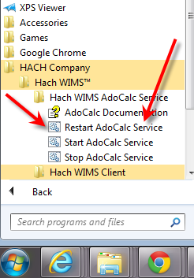

## 1.8.1 INI Files

Services in Hach WIMS use INI files to set up some basic initialization settings. All INI files share at least 3 fields. Additional Fields will be listed under each service’s section. INI Files are located under each service’s directory in the Hach WIMS root directory. (Default is C:\Hach-WIMS­­) INI Settings are formatted as ATTRIBUTE=VALUE. In this section we list attributes and which values are acceptable.

***HACHWIMS_CONNECTION_DBTYPE:***

For Hach WIMS (with DB Support), this can be equal to 1 or 2. 1 means MS SQL and 2 means Oracle.

***HachWIMS_Connection_Provider:***

This signifies the OLEDB provider that ADOCALC should use. OraOLEDB.Oracle is the default provider for Oracle.

***HachWIMS_Connection_Datasource:***

This is your Server Name\Instance Name of the Hach WIMS database that this service will interact with.

## 1.8.2 ADOCALC

ADOCALC is the Hach WIMS calculation engine. It should be online and connected to your database at all times. When a Hach WIMS Client calculates data, it sends a calculation request to ADOCALC, the ADOCALC service then performs the calculation and notifies the client that the calc is complete. Example ADOCALC.INI:

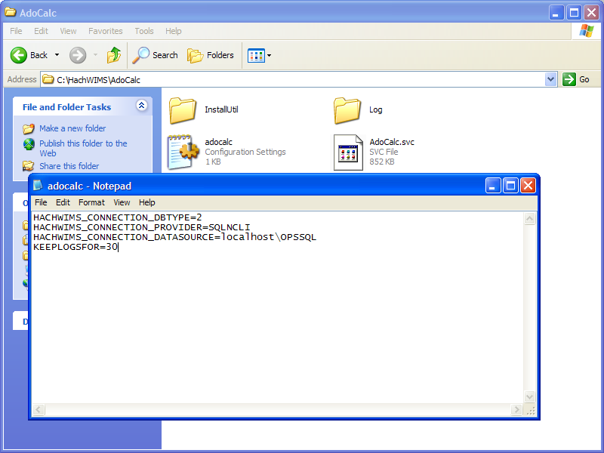

***KEEPLOGSFOR***

The ADOCALC service creates extensive logs of its activity. These logs are located in the log subfolder (default c:\HachWIMS\adocalc\log). This sets the number of days that the log files are kept.

## 1.8.3 DBAHelper

DBAHelper only works with MS SQL Express databases installed by the WIMS installer and therefore is NOT supported with WIMS-MultiUser with Oracle DB support or WIMS Enterprise.

The client is responsible to back up the WIMS database.

## 1.8.4 Email Gateway

The Hach WIMS Email Gateway service is responsible for sending emails that are created by Hach WIMS to a specified SMTP to be delivered via email. For additional information please consult our Knowledge Base. <http://www.opssys.com/instantkb/Article.aspx?id=12003>

The INI File has 6 additional fields.

***KEEPLOGSFOR***

The number of days logs will be saved.

***SMTP***

Specifies the SMTP Server.

***SMTPPORT***

Specifies the port that the SMTP is expecting data to be pushed through.

***SMTPAUTH***

Determines if the SMTP will require authentication (login and password). A value of 1 states authentication is required. Anything else means authentication is not required.

***SMTPUSER***

The Username of this SMTP Server’s authentication. Completed if SMTPAUTH is set to 1.

***SMTPPASSWORD***

The Password for this SMTP Server’s authentication. Completed if SMTPAUTH is set to 1.

## 1.8.5 GNR Server

The Hach WIMS GNR Server service sends scheduled reports and graphs to their scheduled output (email, disk, or a printer). The GNR Service may require additional setup (see below in GNR SETUP section).

The INI File has 2 additional fields.

***KEEPLOGSFOR***

The number of days logs will be saved.

***HACHWIMSCLIENT***

Specifies the path to the Hach WIMS client.

## 1.8.6 Scheduler

The Hach WIMS­­ Scheduler service keeps track of scheduled tasks (database backups, database calculations, scheduled reports, and scheduled graphs) in the Hach WIMS­­ System.

The INI File has 1 additional field.

***KEEPLOGSFOR***

This is the number of days logs will be saved.

## 1.8.7 Watchdog

The Hach WIMS Watchdog service assures all the other services are up and running. When one of its specified services stops illegally, the watchdog service will restart it automatically.

The INI File has 5 additional fields.

***KEEPLOGSFOR***

The number of days logs will be saved.

***POLL_EVERY_MS***

How often watchdog checks in on each service.

***CONNECTION_TIMEOUT_S***

How long watchdog waits for a service before it’s considered timed out.

***STAY_CONNECTED***

***NTSERVICE***

Specifies the name of the NT Service that watchdog needs to track. This entry can be added multiple times to add any NT Service.

# 1.9 GNR Server Service Setup

GNR may require additional setup depending on how your system is configured. GNR Server will need to be logged in as an administrator on the computer it’s installed on. Set up the printer for the GNR administrator user that GNR will have access to (including a PDF Printer).

## 1.9.1 GNR Server Service as Administrator

Services run under the Local System Account do not have access to printer information. In order for the GNR Server to interact with your printers, the GNR Service **MUST** be run under an admin account.

1. Open up Services.msc (go to start->run)

2. The services.msc window will open up. Search for the Hach WIMS GNR Server Service.

3. Right click the Service and select properties.

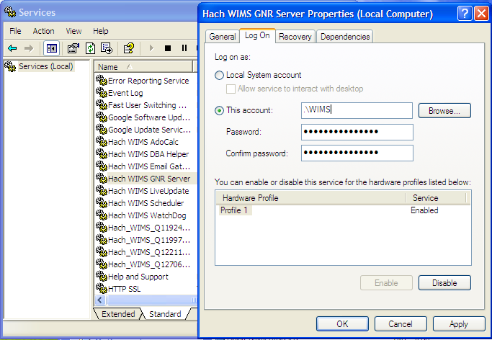

4. Select the Log On Tab.

5. Select the “This Account” Radio button.

6. Type in a Windows administrator’s account Username and Password

7. Click **OK**. This will change the login information for this service.

## 1.9.2 GNR Server PDF Printer

When you set up GNR to run under an administrator account, GNR has access to printers only added to that account. If you would like to have PDF capabilities, you will need to add a PDF Printer to the User account that GNR Server was setup to run under. See <http://www.opssys.com/instantkb/Article.aspx?id=10032> for further instructions and access to files.

1. Login as the Windows User that GNR Server is running under (WIMS in example above)
2. Go to **Start/Settings/Printers And Faxes**
3. Install at least one printer driver. This driver can be a "dummy driver" and does not need to have printer hardware behind it. In case you want the GNR Server to print to multiple print locations, set up all drivers needed.

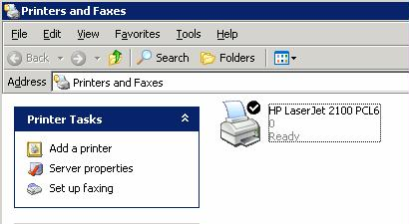

1. Run **pdf995_v12.exe** (Downloaded from Knowledge base article, <http://www.opssys.com/instantkb/article.aspx?id=12741> ). Choose a path where you want to extract the installation files.

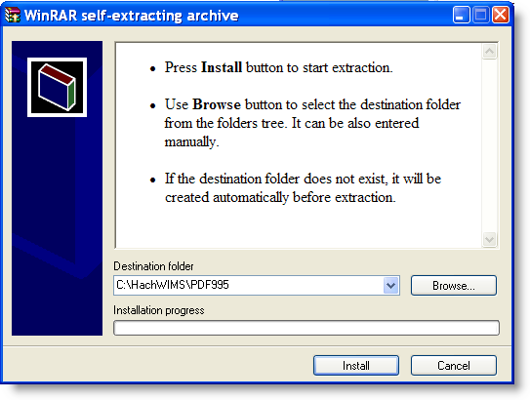

1. Click **Install**. The files will be extracted and the program will close.

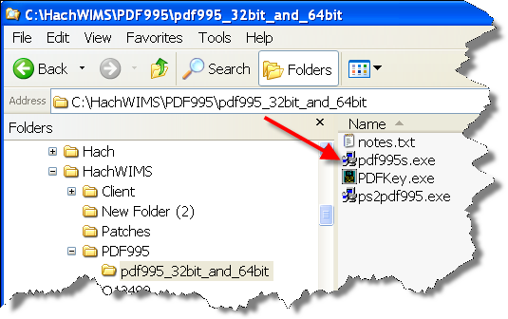

1. In explorer, navigate to the directory where you just extracted the installation files.

1. Run **pdf995.exe**. Let it run through the installation process.
2. Once it’s done, Answer **NO** to the following message:

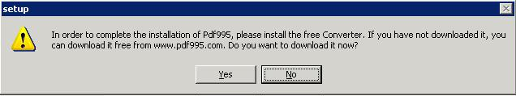

1. Run **ps2pdf995.exe,** answer **Accept** to the Pdf995 User Configuration message that will appear at the end of the install.

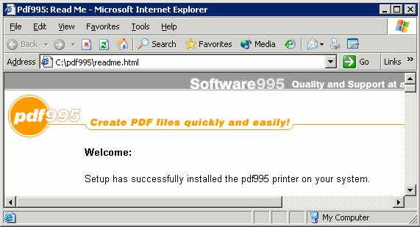

1. The installation will confirm success with a browser message:

1. Run PDFKey.exe
2. Type in your name and the PDF995 key value (pedro3).

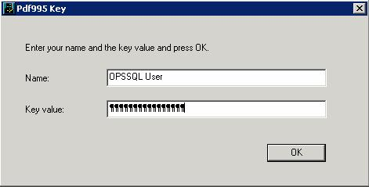

1. Click **OK** and you should see the following message:

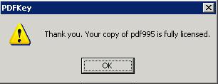

1. Log into the PC as the GNR User. Go to **Start/Settings/Printers and Faxes**

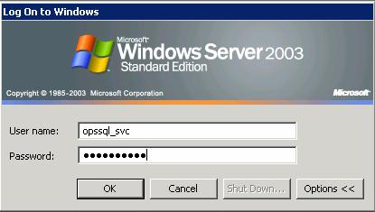

1. PDF995 is in the printers list

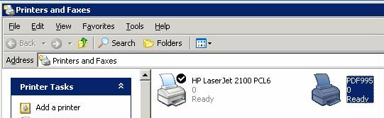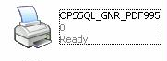

1. Right-Click on **PDF995 and select Rename**
2. Rename to OPSSQL_GNR_PDF995
3. **Right click on OPSSQL_GNR_PDF995** and select **Properties**:

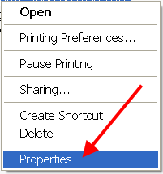

1. Set the OPSSQL_GNR_PDF995 Printer property on the advanced tab to "Start Printing immediately":   
     
     
   **NOTE:** This step addresses several issues users have had when emailing PDFs though GNR Server. Use **PDFSLEEPEXTRAMS** [Hach_WIMS_Client.ini](http://www.opssys.com/instantkb/Article.aspx?id=10447) setting if needed (typically not required).

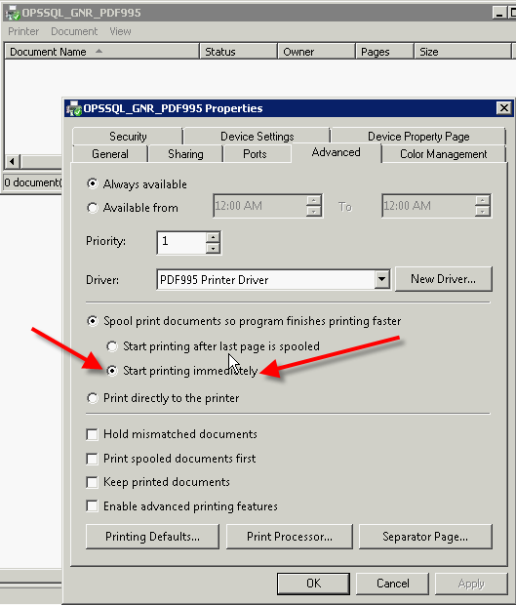

1. In Explorer, navigate to the Hach WIMS­­ Client folder
2. Open Hach_WIMS_Client.INI and add the following 3 settings at the end of the file:

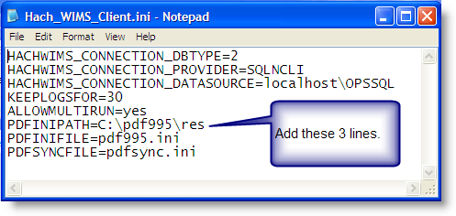

PDFINIPATH=C:\pdf995\res

PDFINIFILE=pdf995.ini

PDFSYNCFILE=pdfsync.ini

1. Save Hach_WIMS_Client.INI
2. Start the GNR Server Service.

# 1.10 Updating the Hach WIMS Client

Updates are periodically released to fix bugs and add minor features to the Hach WIMS­­ system. The Hach WIMS support portal contains the update software to download.

Extract the update. Push the update into the server. Tell the server to disallow any user below a certain version. As users login, they will be forced to update.

1. Visit [www.hachiim.com/support](http://www.hachiim.com/support)
2. If you do not have an account, create one. Log in.
3. If you created your account you will need to add your product License number.
4. Enter the Hach WIMS­­ Support area.
5. Download the latest version of the Hach WIMS­­ Client.
6. The Client update is an EXE that will extract a Setup Program. Run this EXE and extract the files.
7. You will need to run **Server Setup. Start->All Programs->Hach Company->Hach WIMS­­->Hach WIMS Server Setup (Oracle)>Server Setup (Oracle Edition)** and **login**.
8. Go to the **Upload Updates** Tab.

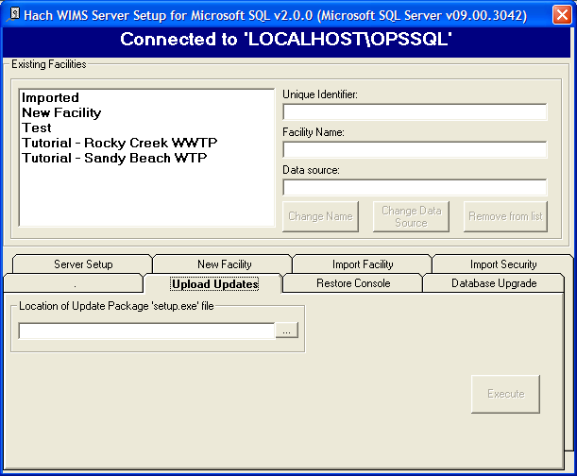

1. Browse to the location where you extracted the update. Select **Setup.exe**
2. Once you select the setup EXE you will be presented with basic information, such as the version number for the update. You will need this number for later.
3. Once the Update has been loaded, close Server Setup and Open the Hach WIMS­­ Client.

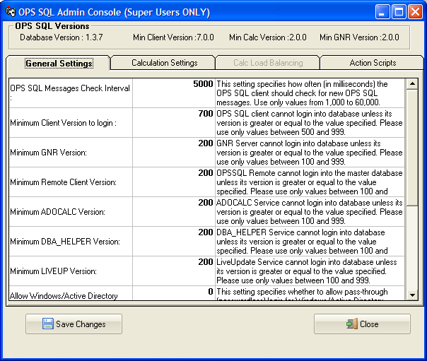

1. The update is stored in the database as a blob file that can be retrieved by any client. To force the clients to update, **Open System Setup->Admin Console**.

1. Change the setting called “Minimum Client Version to Login:” to the version number that was just download without any periods (7.4.1 is typed in as 741) when a client tries to connect to the server that does not meet this requirement, they will be asked to confirm an update to their client.

# 1.11 Hach WIMS User Messages

Hach WIMS comes with a messaging system that allows any Hach WIMS user to send a message to any other Hach WIMS user.

The Hach WIMS Services (ADOCALC, DBA_Helper, interfaces, etc) will use these user messages to report about their behaviors. You can also apply a user message to ‘ping’ the Services.

To Send a Message to a user or service, go to *Utilities*, *Send Message*:

To open your Inbox go to Utilities-> Message Inbox.

# 1.12 Backing up a WIMS Facility

In Hach WIMS (DB Support and Enterprise Editions), you must backup your database using your own Database Management software.

# 1.13 Restoring a Hach WIMS Backup

In Hach WIMS (DB Support and Enterprise Editions), you must restore your databases using your own Database Management software.

# 1.14 Export/Import Utility

WIMS facilities can be exported from Oracle using the Oracle Export Utility. This chapter describes how to use the Export utility to write data from an Oracle database into an operating system file in binary format. This file is stored outside the database, and it can be read into another Oracle database using Oracle’s Import utility. Hach may request an exported WIMS facility for Tech Support purposes.

1. Logon to a PC with the Oracle Export utility installed. The Exp.exe program is distributed by Oracle Corp to the C:\oracle\ora81\bin by default.
2. Get to the command line prompt. Type “Exp Username/Password@Service” as shown below. NOTE: The Username must be a DBA with EXP_FULL_DATABASE role to perform this task. To Export the OPSRTUT (OPS Rocky Tutorial) using the system account from the EmranOPS Oracle Service:

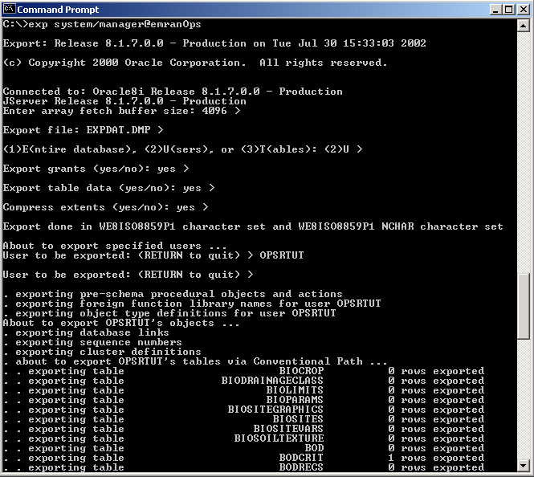

This will create a file called EXPDAT.DMP in the current folder.   
  
  
  
  
  
  
  
  
  
To Import the facility data (OPSRTUT) from an existing export dump file to a different Oracle Service:

1. Create a blank facility (user/schema owner). In this case “OPSRTUT”. Use Ops Server Setup Utility to create the OPSRTUT facility. Check “Do not create any Facility Objects”.

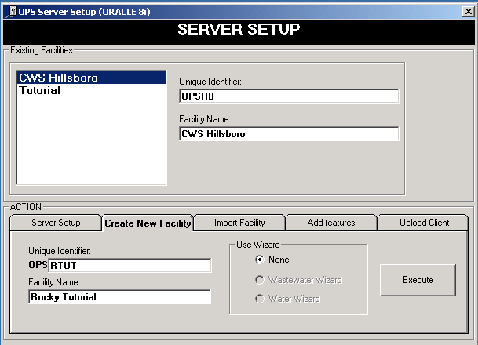

**NOTE**: If you are importing the schema to a Service that already has a schema with the same name, the import will not work. For example, if OPSRTUT already exists on the database you are importing to, the import will not work. To overwrite the schema you drop the user and perform Step 1 above to create the facility with no Facility Objects. To drop a user in DBA Studio, go to security, highlight the user (OPSRTUT in this case), right click, choose delete, and choose to cascade the delete to all objects.

1. From the command line prompt, type “Imp Username/Password@Service” as shown below.   
     
   **NOTE**: The Username must be a DBA with EXP_FULL_DATABASE role to perform this task. To Import the OPSRTUT (Rocky Tutorial) using the system account into the ScottOPS Oracle Service:

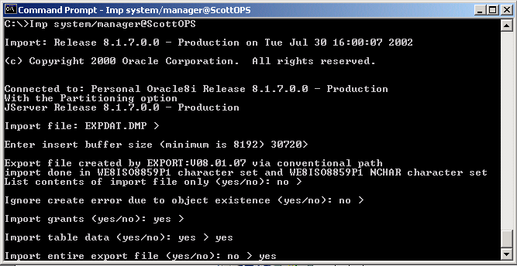

The facility will be imported.

**WARNING: Import overwrites existing table data if the Facility (User/schema owner) already exists.**

# Appendix A: Enabling Relaying on your Email Server for Hach WIMS

The GNR service allows Hach WIMS to send periodic emails, however Hach WIMS itself is not an email server. You must have a machine with an SMTP (email) server already setup. The PC on which the GNR service resides must be able to connect and use your SMTP server to actually send the email. This is called “relaying”. By default, relaying is usually disabled as a security consideration. Enable relaying for the PC that is hosting the GNR service.

This guide will explain how to do this through Microsoft Exchange 2003, a popular email server.

**NOTE:** If you don’t feel comfortable with modifying Exchange settings, which can have far-reaching effects, have your system administrator help you!

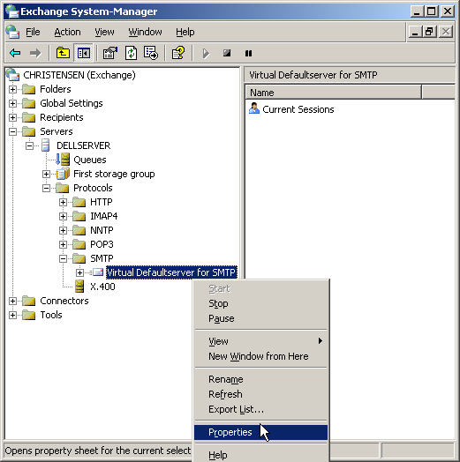

1. Open the Exchange System Manager console and navigate through the tree to Servers/Protocols/SMTP/Default SMTP Virtual Server:

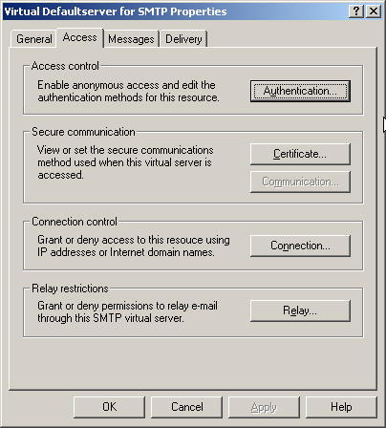

1. Click Properties and then click the Access tab:

The Access Control, Connection and Relay Restriction options will need to be modified in order for email to go through. Modification might be unnecessary if your exchange server has already been setup properly.

1. Click the Authentication tab and make sure that the Anonymous Access option is enabled, as the GNR service does not authenticate as a specific user:

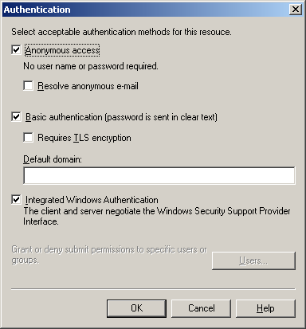

1. Mark the checkbox for Anonymous access and click **OK** to get you back to the Access tab.

1. Click on Connection. Make sure that the machine’s IP address that is hosting the GNR service is either listed as an allowed IP address, or is NOT listed as a blacklisted IP address.

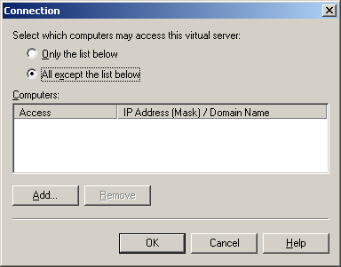

The two radio buttons, “Only the list below” and “All except the list below” control whether the listed IP addresses/Hostnames are either white-listed or black-listed. E.g., if the radio button “Only the list below” is selected and the GNR machine is NOT listed, email sending will not work because the machine is not in the white list; if it’s present in the list, all is OK. Conversely, if the radio button “All except the list below” is checked and the GNR machine IP address/hostname is NOT listed, email will work, while it’s in the list, it is black-listed and will get rejected.

Assure that the IP address is present in the list if the first radio button is selected, or assure it’s NOT present if the second radio button is selected. Click OK to go back to the Access tab.

1. Click the **Relay** button to go to the Relay screen. This screen is similar to the Connection screen:

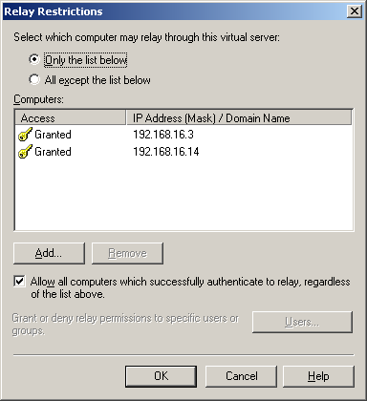

The logic is the same as in the allowed connections screen, i.e., the “Only the list below” radio button controls the white-list and you MUST make sure the GNR machine is listed, while the “All except the list below” button controls the black-listed machines and you MUST make sure the machine is NOT listed. Click **OK**.

1. Disable your anti-virus program on the SMTP (email server) machine. This is necessary because the anti-virus program interferes with the way Hach WIMS sends emails.

**NOTE**: Modifying email settings can have serious security consequences. Please have your system or network administrator help you or do the actual modifications if necessary!